Sample Media Advisories
For Pitching to News Assignment/Planning Desks

***MEDIA ADVISORY***

Highlight of Tucson Gem & Mineral Show/Unique Visual for Photo/Video:

Never Before Have So Many “Round Rocks” With Such Variety Been Gathered in One Place!

Sphere Expert Calls It Quits Resulting in the World’s Largest Sphere Sale

Who: Nearly 20 years ago, Jackie Lapin embarked on a journey that made her the leading seller of mineral spheres and natural mineral marbles in the world. She sold to high-end collectors, sphere enthusiasts, people who wanted to create models of the Universe, professors, youngsters, metaphysical healers, movie producers, marble collectors and more. Her company Sphere’s To You became the go-to provider of spheres from around the world. She sought out unique materials from Spain, Russia, Poland, South Africa, Australia, and even the Sahara Desert. Many of those still remain in the inventory being sold at Tucson.
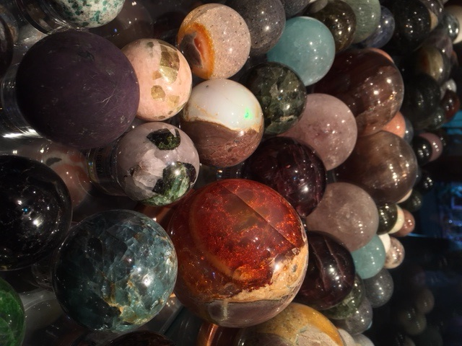
Lapin is calling it quits, but loves to tell the story behind the beautiful spheres currently in her possession.

What: The Tucson Gem & Mineral Show will be the site of “The World’s Largest Sphere Sale!” The world’s leading seller of mineral spheres and natural mineral marbles is liquidating its stock! Nearly all of the company’s 3,000+ spheres are being offered as the company liquidates after 20 years in business. Collectors, dealers and healers will be gathering to grab up gorgeous gemstone, fossil (including dinosaur bone) , crystal, petrified wood, opal, jade, fluorescent, agate, translucent, starred, chatoyant spheres, marbles and more from around the world. Much of this inventory has been out of circulation for years—so there is still high quality material that may now be hard to get.

Where: Hotel Tucson City Center, Feb 1- Feb. 13. Room 334-335

When: Feb 1- Feb. 13, 9-6 p.m. Please call in advance.

Contact: Jackie Lapin (818) 317 6074 (call or text) jackie@jackielapin.com

***M E D I A A D V I S O R Y***

LA POKER CLASSIC AT COMMERCE CASINO TO DRAW
600 + WORLD CLASS POKER PLAYERS FOR $7+ MILLION PRIZE POOL

WHAT: The LA Poker Classic, a WORLD POKER TOUR® (WPT) event at the Commerce Casino will draw a 600-1000 poker players…a combination of leading pros and talented amateurs…vying for a prize pool that is expected to exceed $7 million. Both numbers will set records for a Los Angeles poker tournament. 25-year-old Antonio “The Magician” Esfandiari , who won $1.4 million in 2004 returns to defend his title. Daniel Negreanu leads contenders for WPT Player of the Year and will try to extend his lead. Negreanu has already won more than $3 million on the WPT Tour this year. The WPT Tour has a total prize pool expected to exceed $70+ million for the season.

WHEN: The Tournament Schedule:

Friday, Feb. 18, 2:30-6:00 p.m./LA Poker Classic, Tournament play

begins at 3:30 p.m. Registration and early rounds of World Poker

Tour No Limit Texas Hold ‘Em Event—LA Poker Classic.

Tuesday, Feb. 22, Play begins at 5 p.m./LA Poker Classic
Final Table for LA Poker Classic. Down to the six “survivors.” Cut-throat poker for millions of dollars.

INTERVIEWS: World Poker Tour creator Steve Lipscomb, the man behind the poker phenomenon. The hottest players in poker: Daniel Negreanu, John Juanda, Kathy Liebert, Phil “the Unabomber” Laak, Gus “The Great Dane” Hansen, Phil “Poker Brat” Hellmuth, T.J. Cloutier, Jennifer Harman, Howard Lederer, Barry Greenstein (who gives his million-dollar winnings to charity) and others. Hosts: Mike Sexton, Vince Van Patten and Shana Hiatt.

WHERE: The Commerce Casino, 6131 East Telegraph Rd, Los Angeles (7 minutes from downtown LA, off Washington exit on Interstate 5.) Phone: (323) 721-2100.

CONTACT: In advance: Jackie Lapin (818) 707-1473 or Jim Llewellyn (323) 810 7685. Day of event: (818) 317 6074 or (323) 810 7685, or if not answering immediately (818) 707-1473. Email Contact: jackielapin@yahoo.com.

