Mini Media Kit Sample
For Providing to
Virtual Summit Hosts

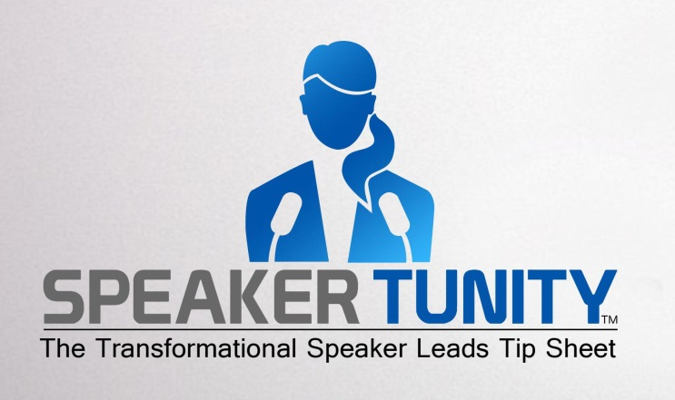

Jackie Lapin
SpeakerTunity™ Founder

Jackie Lapin is a leader in helping transformational leaders, authors, coaches, health practitioners, speakers and messengers connect with their next followers around the globe. For the past 10 years, her internationally acclaimed Conscious Companies have been providing PR campaigns, radio media tours and speaking engagements to support the growth and revenue of change-makers. Her clients have included Don Miguel Ruiz, Dr. Joe Vitale, James Twyman, Denise Linn, Arielle Ford, Hay House and more.

Today, as “The Transformational Connector,” she provides resources and guidance through her SpeakerTunity™ programs and tip sheets that get changemakers booked for speaking engagements, radio shows, podcasts and virtual summits across North America. Jackie has personally booked more than 10,000 interviews and speaking engagements over the past years—and she is here today to share her wisdom with us.
.

SpeakerTunity™

SpeakerTunity™, the twice monthly transformational speaker leads tip sheet, providing speakers with the direct contacts to book themselves on stages across North America! (www.Speakertunity.com)

This subscription-based service provides insight on speaking opportunities in hot regions of U.S. and Canada, top book tour sites, local chapters of national organizations, local grass roots organizations, multi-speaker events and expos, conferences and conventions, leading Spiritual Living Centers, Unity and Christian churches, wellness events, yoga centers, women’s organizations, fraternal organizations, chambers of commerce, resort and retreat centers and more!

SpeakerTunity™ includes the direct contact, phone number, email, website and--when required--a link to the online form to fill out--across the US and Canada. Then--with one email, phone call or filled out form—a speaker will be changing lives, selling books, enrolling people in coaching programs or building business in that truly amazing face-to-face way.

And...

SpeakerTunity Radio Insider™ provides 25+ leads per month to radio shows that welcome transformational content.

SpeakerTunity Summits™ gives subscribers the latest updates on which Virtual Summits are seeking guest presenters and those who may already have filled their immediate summit but are open for the future.

The Presentation

VISIBILTY: The Key to Attracting New Clients and Changing More Lives

There people out there waiting to hear you! They need what you offer--your inspiration, guidance, wisdom, coaching, books and products. And the only barrier for them becoming your next client or raving fan is they just don’t know about you!

In order to grow your business, you have to be visible! You must reach these new prospects where they already are—at events, meetings and venues; on radio, and on virtual summits!

Find out EXACTLY what it takes to be a sought-after superstar to get booked time and again for all of these!

- How do you get your speaking calendar revved up and rocketing
- How to find the radio shows and podcasts that will give you a great showcase and connect you with their legions of listeners
- How to get on the virtual summit circuit and start building your list and leads
- How you can get bookers to say “yes” to consistently
Questions
- What should one do to start building a calendar of speaking opportunities?
- Give us some sample ways to find local engagements?
- How do you find conferences?
- How do you get on other people’s stages?
- How do you find the radio shows that are aligned with one’s message?
- What are the best ways to find podcasts?
- Why are virtual summits important for a leader or expert to cultivate?
- What do you have to do to get on the “summit circuit?
- If you want to get on virtual summits, how do you find them?
- Are there easy ways to find these opportunities?
Learn More
- SpeakerTunity™ Transformational Speaker Leads Tip Sheet:, SpeakerTunity Radio Insider™, and SpeakerTunity Summits™
www.Speakertunity.com

- Get Booked Training Program www.GetbookedTraining.com

- Conscious Media Relations : www.ConsciousMediaRelations.com

Social Network Connections

- Facebook: http://www.facebook.com/speakertunity
- Twitter: https://twitter.com/SpeakerTunity
- LinkedIn: https://www.linkedin.com/in/jackielapin

